

**American International University-Bangladesh (AIUB)**  
 Department of Computer Science

Faculty of Science & Technology (FST)

**PROJECT TITLE: DoorBell**

**Semester: Fall 25-26**

|  |  |  |
| --- | --- | --- |
| ***Group: 09*** | | ***Section: S*** |
| **SL** | **Student Name** | **Student ID** |
| 1 |  |  |
| 2 |  |  |
| 3 |  |  |
| 4 |  |  |
| 5 |  |  |

1.PROJECT PROPOSAL



1.1 Background to the Problem

Finding reliable home service providers is a common problem. People often need services such as house cleaning, gardening, plumbing, or electrical repair, but they usually do not know whom to contact. They depend on friends’ suggestions or online searches, which can be time-consuming and unreliable. In many cases, the service quality is poor or the workers are not trustworthy.

Service workers also face difficulties. Skilled cleaners, electricians, and gardeners often struggle to find enough customers. Managing schedules, keeping track of bookings, and handling payments manually can be confusing and inefficient. At the same time, service managers find it difficult to monitor workers, customer bookings, and payments using traditional methods.

To address these issues, this project proposes DoorBell, a centralized home service management system. DoorBell is a computer-based platform that connects customers with trusted local service workers. It allows users to book services, schedule appointments, make secure payments, and view service reviews in one place. The system also helps workers manage their assigned jobs and assists managers in organizing services, users, and transactions efficiently.

Who Will Use DoorBell?

1. Homeowners (People who need help)  
   These are people who need someone to clean their house, fix a leak, or take care of their garden. They are busy and want to find a good worker quickly without stress.

* They want to book a service easily.
* They want to know the worker is trusted and skilled.
* They want to pay safely online.
* They want to read reviews from other customers.

1. Service Workers (People who provide help)  
   These are the cleaners, gardeners, electricians, and plumbers who do the work. They want to find more customers and keep their work organized.

* They need to see their job list for the day or week.
* They want to know the customer's address and details.
* They need to manage their schedule.
* They want a simple way to update their profile and availability.

1. Managers (People who run the system)  
   This is the admin person who makes sure DoorBell runs smoothly. They manage everyone and everything on the platform.

* They add or remove workers and services.
* They look at all bookings and payments.
* They solve problems if something goes wrong.
* They make sure the quality of service is good and customers are happy.

DoorBell helps all three groups work together smoothly, making home services simple and trustworthy for everyone.

1.2 Selection of Process Model

**Process Model Selection (Scrum)**

The Scrum framework is used for this project as it has several features and roles for the users, and there might be changes while carrying out the development process. It is an agile technique that allows frequent improvements and changes as it has short sprints that ensure effective delivery within an academic team setup.

**Reason for Using the Scrum Model**

The Scrum pattern has been selected for the DoorBell project because it allows the complex system to be developed in a structured and flexible manner. The DoorBell system comprises a number of functionalities like user registration/login, service booking, payment handling, profile management, review systems, and admin panels. It is a difficult task to implement all functionalities simultaneously. Scrum allows the whole process to be divided into smaller tasks referred to as sprints, which allows the entire process to be more organized.

The project also consists of various user roles, which include general users, service providers (employees), and an admin. Each role consists of diverse requirements and features. Scrum facilitates prioritizing the requirements in a product backlog and then executing them one by one, which is a wise way to manage features for various roles and ensure that users receive the right functionalities.

Another key reason why Scrum should be considered in projects involves change in project requirements that can occur while development takes place. This applies in academic projects where changed requirements based on evaluations from lecturers or project supervisors are needed, and Scrum allows this without any impact due to previously accomplished work.

Apart from increasing efficiency, Scrum enhances team working and collaboration. Since the project will be developed by a team within a short semester period, the application of Scrum will enable the team to break down their duties effectively. In every sprint, the team will deliver a functioning version of the system, allowing the team to identify mistakes promptly. With this understanding, the Scrum model is efficient for the application in the DoorBell project.

**2 .Product Requirements Document**

|  |  |  |  |
| --- | --- | --- | --- |
| As A/An | I want to | so That | Acceptance Criteria |
| admin | As a new user  I want to create an account  using phone/email | So that I can  access the  service platform. | Signup must verify a valid and unused email, ensure the  password is at least eight  characters and matches the re- entered password, and require selecting a user type. On successful signup, the user is saved in the database,  redirected to the dashboard, and  sent a confirmation email. |
|  | As a registered user  I want to log in securely with my credentials | So that I can access my dashboard. | Sign in must confirm that the email and password match the database; otherwise, an error message appears. Users must be able to navigate to signup and password recovery pages from here. |
|  | I want to reset my forgotten password | So that I can  recover access | The system must confirm the email exists, send a reset code, and require a valid new  password and matching confirmation. If valid, the  password updates successfully; otherwise, clear error messages  appear. |
|  | I want to  manage all system  information | So that I can control services, users, and business data. | The admin menu must correctly open service modules, user  tables, service tables, |

|  |  |  |  |
| --- | --- | --- | --- |
|  |  |  | transactions, bookings, and profile options. |
|  | I want to view my stored  information | So that I can verify and manage my  account | The profile page must show all user data without blanks and  allow navigation to edit profile. |
|  | I want to update my personal  info | So that my profile stays accurate. | Editing must validate email  format, phone number, and age, then save changes or show errors. |
|  | I want to change my profile picture | So that I can  personalize my account. | Users may upload only PNG/JPG images, and after confirming, the system must show the  updated photo. |
|  | I want to change my password | So that I can keep my account secure. | The system must verify the current password, validate the new one, and update it or show an error. |
|  | View Service Table | I can update existing services | Table with update/edit options |
|  | View Transactions | I can track all payments | Transaction list displayed with filters |
|  | Log out | I can exit the  system securely | Redirects to login screen |
|  | View payment breakdown (when needed) | I can confirm cost structure | Shows full cost breakdown clearly |
|  |  |  |  |
| employee | As a new user  I want to create an account  using phone/email | So that I can  access the  service platform. | Signup must verify a valid and unused email, ensure the  password is at least eight  characters and matches the re- entered password, and require selecting a user type. On successful signup, the user is saved in the database,  redirected to the dashboard, and sent a confirmation email. |

|  |  |  |  |
| --- | --- | --- | --- |
|  | As a registered user  I want to log in securely with my credentials | So that I can access my dashboard. | Sign in must confirm that the email and password match the database; otherwise, an error message appears. Users must be able to navigate to signup and password recovery pages from here. |
|  | I want to reset my forgotten password | So that I can  recover access | The system must confirm the email exists, send a reset code, and require a valid new  password and matching confirmation. If valid, the  password updates successfully; otherwise, clear error messages appear. |
|  | I want to  manage all system  information | So that I can  complete tasks and track work. | The dashboard must show service lists, work lists,  bookings, profile, and logout, all functioning properly. |
|  | I want to view my stored  information | So that I can verify and manage my  account | The profile page must show all user data without blanks and  allow navigation to edit profile. |
|  | I want to update my personal  info | So that my profile stays accurate. | Editing must validate email  format, phone number, and age, then save changes or show errors. |
|  | I want to change my profile picture | So that I can  personalize my account. | Users may upload only PNG/JPG images, and after confirming, the system must show the  updated photo. |
|  | I want to change my password | So that I can keep my account secure. | The system must verify the current password, validate the new one, and update it or show an error. |
|  | Use “All Servicesˮ button | I can see available service categories | Displays all categories with icons |

|  |  |  |  |
| --- | --- | --- | --- |
|  | View service details | I can prepare for the work | Shows customer info & location |
|  | View work list | I can track tasks | Shows all assigned bookings |
|  | View my bookings | I can review my completed services | Booking list with status |
|  |  |  |  |
| User | As a new user  I want to create an account  using phone/email | So that I can  access the  service platform. | Signup must verify a valid and unused email, ensure the  password is at least eight  characters and matches the re- entered password, and require selecting a user type. On successful signup, the user is saved in the database,  redirected to the dashboard, and sent a confirmation email. |
|  | As a registered user  I want to log in securely with my credentials | So that I can access my dashboard. | Sign in must confirm that the email and password match the database; otherwise, an error message appears. Users must be able to navigate to signup and password recovery pages from here. |
|  | I want to reset my forgotten password | So that I can  recover access | The system must confirm the email exists, send a reset code, and require a valid new  password and matching confirmation. If valid, the  password updates successfully; otherwise, clear error messages appear. |
|  | I want to see a clean menu of services (Gardening,  Cleaning, Plumbing) | So that I can control services, users, and business data. | The dashboard must show service categories, bookings, profile access, and logout, with all options linking correctly. |

|  |  |  |  |
| --- | --- | --- | --- |
|  | I want to view my stored  information | So that I can verify and manage my  account | The profile page must show all user data without blanks and  allow navigation to edit profile. |
|  | I want to update my personal  info | So that my profile stays accurate. | Editing must validate email  format, phone number, and age, then save changes or show errors. |
|  | I want to change my profile picture | So that I can  personalize my account. | Users may upload only PNG/JPG images, and after confirming, the system must show the  updated photo. |
|  | I want to change my password | So that I can keep my account secure. | The system must verify the current password, validate the new one, and update it or show an error. |
|  | View clean service menu | I can quickly choose a service | Shows Gardening, Cleaning, Electrical |
|  | View specific service details | I understand what Iʼm booking | Shows details, pricing, available employees |
|  | Log out | I can exit safely | Redirect to login |
|  | Choose payment method | I can complete booking | Must select one method; success/failure message |
|  | Make secure payment | My booking becomes confirmed | payment success → “Paidˮ; failure → error shown |

**2.1 Project Scope and Features**

The **DoorBell – Home Service Management System** is a web-based platform designed to digitalize and streamline the connection between homeowners and trusted local service providers. The project aims to replace inefficient, manual methods of finding and booking services with a secure, user-friendly, and role-based system. It enhances accessibility, ensures service quality, and brings transparency to scheduling, payments, and reviews.

This system will serve three primary user roles: **Admin, Employee (Service Provider), and Customer (Homeowner)**. It will support end-to-end operations including service discovery, online booking, automated scheduling, secure payment processing, and centralized management.

**Key Features**

The system’s functionality is divided based on user roles. The key features for each role are outlined below.

**1) Admin Features**

The Admin is the system supervisor with the highest level of access, responsible for overall platform management, user oversight, and system configuration.

**Key functionalities:**

* Login securely using admin credentials.
* Manage all user accounts (Customers and Employees)—create, view, update, and delete.
* Manage the service catalogue—add, update, search, and delete services (e.g., Cleaning, Gardening).
* View and monitor all bookings and transactions in real-time.
* Generate and export transaction reports to Excel/PDF.
* Update personal admin profile (username and role are unchangeable).
* Configure system settings (service categories, business hours, payment methods).
* View all customer ratings and reviews.
* Handle and resolve reported issues or disputes.
* Search transactions and bookings by date, user, or service type.
* Log out users remotely if necessary.
* Ensure data consistency and system performance.

**2) Employee (Service Provider) Features**

The Employee is a verified service professional (e.g., cleaner, electrician, gardener) who uses the platform to receive job assignments and manage their work.

**Key functionalities:**

* Login securely with employee credentials.
* View a personalized dashboard with upcoming and assigned jobs.
* See detailed job information, including customer details, service address, and special instructions.
* Update job status (e.g., Accepted, On the way, Completed).
* View personal work history and completed services.
* Update personal profile, including contact information, skills, and availability.
* Change account password securely.
* Upload or change a profile picture.
* Access a list of all available service categories.
* Receive notifications for new job assignments.

**3) Customer (Homeowner) Features**

The Customer is a homeowner seeking reliable home services. They interact with the platform to find, book, and pay for services.

**Key functionalities:**

* Register an account and login securely.
* Browse and search for services by category (Cleaning, Gardening, Plumbing, Electrical, etc.).
* View detailed service descriptions, pricing, and available service providers.
* Book a service by selecting a date, time, and preferred provider.
* Choose from secure online payment methods.
* View a detailed breakdown of costs before confirming payment.
* Track the status of current and past bookings.
* View and download payment receipts.
* Update personal profile information (name, email, phone, address).
* Change account password and profile picture.
* Provide ratings and reviews for completed services.
* Log out of the system securely.

2.2 User Story Table

|  |  |  |  |
| --- | --- | --- | --- |
| As A/An | I want to | so That | Acceptance Criteria |
| admin | As a new user  I want to create an account  using phone/email | So that I can  access the  service platform. | Signup must verify a valid and unused email, ensure the  password is at least eight  characters and matches the re- entered password, and require selecting a user type. On successful signup, the user is saved in the database,  redirected to the dashboard, and  sent a confirmation email. |
|  | As a registered user  I want to log in securely with my credentials | So that I can access my dashboard. | Sign in must confirm that the email and password match the database; otherwise, an error message appears. Users must be able to navigate to signup and password recovery pages from here. |
|  | I want to reset my forgotten password | So that I can  recover access | The system must confirm the email exists, send a reset code, and require a valid new  password and matching confirmation. If valid, the  password updates successfully; otherwise, clear error messages  appear. |

|  |  |  |  |
| --- | --- | --- | --- |
|  | I want to  manage all system  information | So that I can control services, users, and business data. | The admin menu must correctly open service modules, user  tables, service tables,  transactions, bookings, and profile options. |
|  | I want to view my stored  information | So that I can verify and manage my  account | The profile page must show all user data without blanks and  allow navigation to edit profile. |
|  | I want to update my personal  info | So that my profile stays accurate. | Editing must validate email  format, phone number, and age, then save changes or show errors. |
|  | I want to change my profile picture | So that I can  personalize my account. | Users may upload only PNG/JPG images, and after confirming, the system must show the  updated photo. |
|  | I want to change my password | So that I can keep my account secure. | The system must verify the current password, validate the new one, and update it or show an error. |
|  | View Service Table | I can update existing services | Table with update/edit options |
|  | View Transactions | I can track all payments | Transaction list displayed with filters |
|  | Log out | I can exit the  system securely | Redirects to login screen |
|  | View payment breakdown (when needed) | I can confirm cost structure | Shows full cost breakdown clearly |
|  |  |  |  |
| employee | As a new user  I want to create an account  using phone/email | So that I can  access the  service platform. | Signup must verify a valid and unused email, ensure the  password is at least eight  characters and matches the re- entered password, and require selecting a user type. On successful signup, the user is |

|  |  |  |  |
| --- | --- | --- | --- |
|  |  |  | saved in the database,  redirected to the dashboard, and sent a confirmation email. |
|  | As a registered user  I want to log in securely with my credentials | So that I can access my dashboard. | Sign in must confirm that the email and password match the database; otherwise, an error message appears. Users must be able to navigate to signup and password recovery pages from here. |
|  | I want to reset my forgotten password | So that I can  recover access | The system must confirm the email exists, send a reset code, and require a valid new  password and matching confirmation. If valid, the  password updates successfully; otherwise, clear error messages appear. |
|  | I want to  manage all system  information | So that I can  complete tasks and track work. | The dashboard must show service lists, work lists,  bookings, profile, and logout, all functioning properly. |
|  | I want to view my stored  information | So that I can verify and manage my  account | The profile page must show all user data without blanks and  allow navigation to edit profile. |
|  | I want to update my personal  info | So that my profile stays accurate. | Editing must validate email  format, phone number, and age, then save changes or show errors. |
|  | I want to change my profile picture | So that I can  personalize my account. | Users may upload only PNG/JPG images, and after confirming, the system must show the  updated photo. |
|  | I want to change my password | So that I can keep my account secure. | The system must verify the current password, validate the new one, and update it or show an error. |

|  |  |  |  |
| --- | --- | --- | --- |
|  | Use “All Servicesˮ button | I can see available service categories | Displays all categories with icons |
|  | View service details | I can prepare for the work | Shows customer info & location |
|  | View work list | I can track tasks | Shows all assigned bookings |
|  | View my bookings | I can review my completed services | Booking list with status |
|  |  |  |  |
| User | As a new user  I want to create an account  using phone/email | So that I can  access the  service platform. | Signup must verify a valid and unused email, ensure the  password is at least eight  characters and matches the re- entered password, and require selecting a user type. On successful signup, the user is saved in the database,  redirected to the dashboard, and sent a confirmation email. |
|  | As a registered user  I want to log in securely with my credentials | So that I can access my dashboard. | Sign in must confirm that the email and password match the database; otherwise, an error message appears. Users must be able to navigate to signup and password recovery pages from here. |
|  | I want to reset my forgotten password | So that I can  recover access | The system must confirm the email exists, send a reset code, and require a valid new  password and matching confirmation. If valid, the  password updates successfully; otherwise, clear error messages appear. |
|  | I want to see a clean menu of services | So that I can  control services, | The dashboard must show service categories, bookings, |

|  |  |  |  |
| --- | --- | --- | --- |
|  | (Gardening, Cleaning,  Plumbing) | users, and business data. | profile access, and logout, with all options linking correctly. |
|  | I want to view my stored  information | So that I can verify and manage my  account | The profile page must show all user data without blanks and  allow navigation to edit profile. |
|  | I want to update my personal  info | So that my profile stays accurate. | Editing must validate email  format, phone number, and age, then save changes or show errors. |
|  | I want to change my profile picture | So that I can  personalize my account. | Users may upload only PNG/JPG images, and after confirming, the system must show the  updated photo. |
|  | I want to change my password | So that I can keep my account secure. | The system must verify the current password, validate the new one, and update it or show an error. |
|  | View clean service menu | I can quickly choose a service | Shows Gardening, Cleaning, Electrical |
|  | View specific service details | I understand what Iʼm booking | Shows details, pricing, available employees |
|  | Log out | I can exit safely | Redirect to login |
|  | Choose payment method | I can complete booking | Must select one method; success/failure message |
|  | Make secure payment | My booking becomes confirmed | payment success → “Paidˮ; failure → error shown |

2.3 Requirements Traceability Matrix

2.3.1 Functional Requirements

## Admin Requirements

|  |  |
| --- | --- |
| ID | Requirement Description |
| 1.0 | User Authentication & Dashboard |
| 1.1 | Login |
| 1.1.1 | Input email and password |
| 1.1.2 | Forgot password option |
| 1.1.2.1 | Email verification and reset link/code |
| 1.1.3 | Submit login and redirect to dashboard |
| 1.2 | Dashboard Side Menu |
| 1.2.1 | View Profile |
| 1.2.1.1 | Show name, email, phone, role, profile picture |
| 1.2.1.2 | Edit Profile button |
| 1.2.1.3 | Change Profile Picture button |
| 1.2.1.4 | Change Password button |
| 1.3 | Manage Services |
| 1.3.1 | View service list in table format |
| 1.3.2 | Add new service button |
| 1.3.3 | Edit existing service button |
| 1.3.4 | Delete service with confirmation |
| 1.4 | Manage Users |
| 1.4.1 | View user list (admin, employee, customer) |
| 1.4.2 | Add new user (employee/admin) |
| 1.4.3 | Edit user details |
| 1.4.4 | Delete user with confirmation |
| 1.5 | View Transactions |
| 1.5.1 | View all transactions with filters |
| 1.5.2 | Export transactions to Excel/PDF |
| 1.6 | View Bookings |
| 1.6.1 | View all bookings with status |
| 1.6.2 | Filter by service, date, user |
| 1.7 | System Configuration |
| 1.7.1 | Set service categories |
| 1.7.2 | Configure payment methods |
| 1.7.3 | Manage business hours |
| 1.8 | Logout |
| 1.8.1 | Redirect to login page |

**Employee Requirements**

|  |  |
| --- | --- |
| **ID** | **Requirement Description** |
| 1.0 | User Authentication & Dashboard |
| 1.1 | Login [Ref: Admin 1.1] |
| 1.2 | Dashboard Side Menu |
| 1.2.1 | View Profile [Ref: Admin 1.2.1] |
| 1.2.2 | Edit Profile [Ref: Admin 1.2.1.2] |
| 1.2.3 | Change Password [Ref: Admin 1.2.1.4] |
| 1.3 | View Service List |
| 1.3.1 | See all available service categories |
| 1.3.2 | Click to view service details |
| 1.4 | View Assigned Work |
| 1.4.1 | View all assigned bookings |
| 1.4.2 | View customer info and location |
| 1.5 | View My Bookings |
| 1.5.1 | See completed services with status |
| 1.6 | Logout |
| 1.6.1 | Redirect to login page |

**Customer Requirements**

|  |  |
| --- | --- |
| ID | Requirement Description |
| 1.0 | User Authentication |
| 1.0.1 | Signup with email/phone and password |
| 1.0.2 | Login with credentials |
| 1.0.3 | Reset forgotten password |
| 1.1 | Browse Services |
| 1.1.1 | View service categories (Gardening, Cleaning, etc.) |
| 1.1.2 | View service details, pricing, available employees |
| 1.2 | Book a Service |
| 1.2.1 | Select service and confirm booking |
| 1.2.2 | Choose payment method |
| 1.2.3 | Complete secure payment |
| 1.3 | View My Bookings |
| 1.3.1 | See all past and upcoming bookings |
| 1.3.2 | View payment breakdown |
| 1.4 | Profile Management |
| 1.4.1 | View profile information |
| 1.4.2 | Edit personal details |
| 1.4.3 | Change profile picture |
| 1.4.4 | Change password |
| 1.5 | Logout |
| 1.5.1 | Redirect to login page |

2.3.2 Non-Functional Requirements

|  |  |
| --- | --- |
| 1.0 | Usability |
| 1.0.1 | Role-based intuitive UI (Admin, Employee, User) |
| 1.0.2 | Clear navigation and consistent design |
| 1.0.3 | Meaningful error messages with corrective steps |
| 2.0 | Reliability |
| 2.0.1 | Data consistency in bookings and transactions |
| 2.0.2 | Daily automated backup of database |
| 2.0.3 | System recovery within 30 minutes after failure |
| 3.0 | Security |
| 3.0.1 | Secure authentication for all user types |
| 3.0.2 | Encrypted password storage |
| 3.0.3 | Role-based access control (RBAC). |
| 3.0.4 | Account lock after 5 failed login attempts |
| 4.0 | Maintainability |
| 4.0.1 | Modular design for easy updates |
| 4.0.2 | Editable configuration without code change |
| 5.0 | Scalability |
| 5.0.1 | Support 10,000 registered users |
| 5.0.2 | Handle 1,000 daily transactions |
| 6.0 | Performance |
| 6.0.1 | Dashboard load within 3 seconds |
| 6.0.1 | Booking confirmation within 5 seconds |
| 6.0.2 | Search results within 2 seconds for 50k records |
| 7.0 | Availability |
| 7.0.1 | 99.5% uptime during business hours |
| 7.0.2 | Maintenance outside service hours |
| 8.0 | Scalability |
| 8.0.1 | Support 10,000 registered users |
| 8.0.2 | Handle 1,000 daily transactions |
| 9.0 | Data Storage |
| 9.0.1 | Store 5 years of transaction history |
| 9.0.2 | Retrieve archived data within 10 seconds |

# 3. SOFTWARE DESIGN

**3.1 System Design:**

Draw the system design for your project using **Draw.io** or **LucidChart**.

* Prepare a **Use Case Diagram** by first defining all users (actors) and their roles. Show each actor’s interactions with the system through use cases inside a system boundary. Include relationships like include or extend where needed.

**Use Case Diagram:**

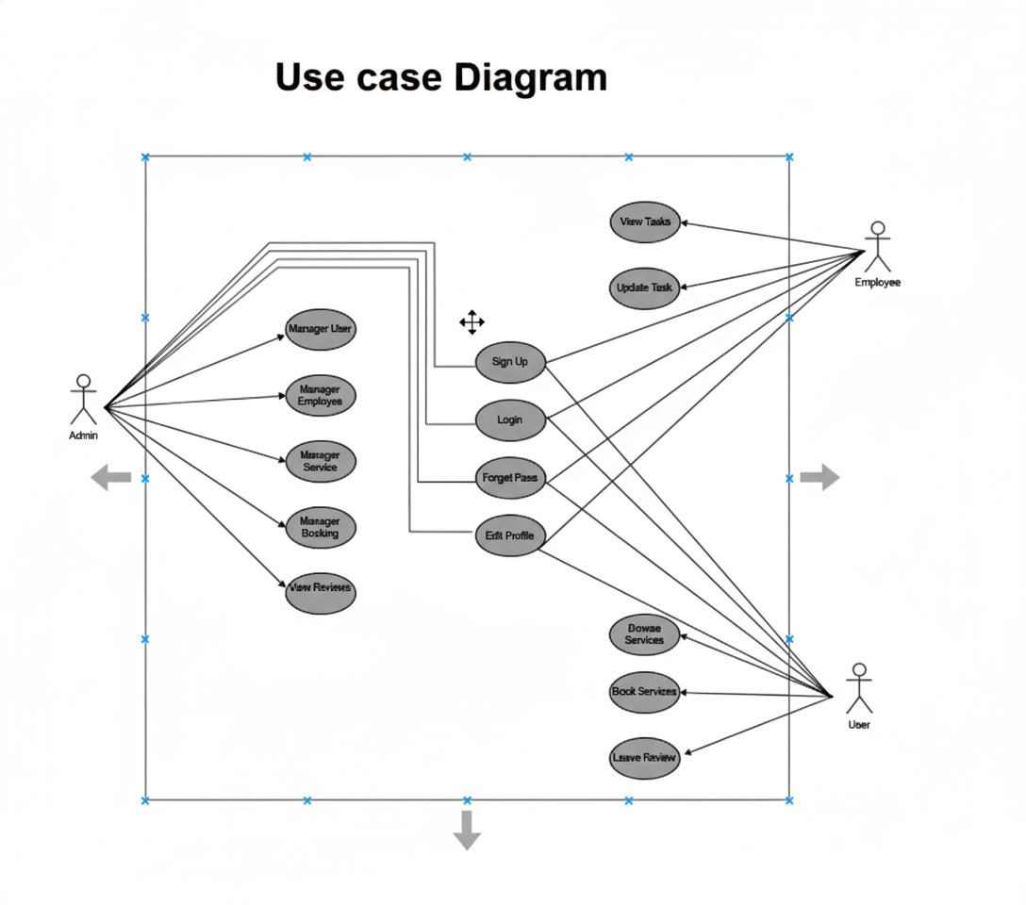

**Class Diagram:**

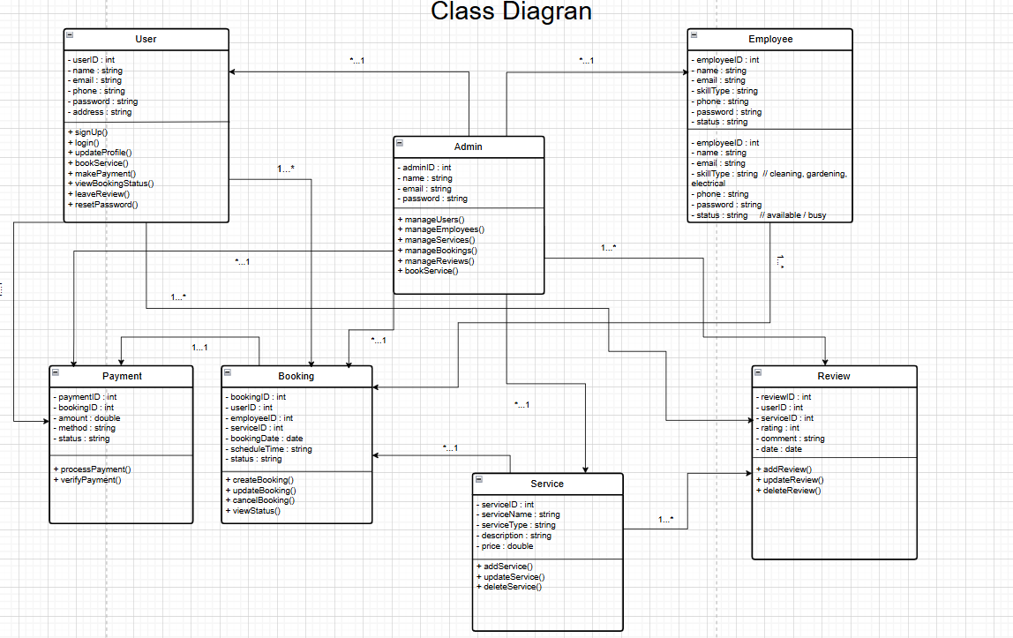

**Activity Diagram:**

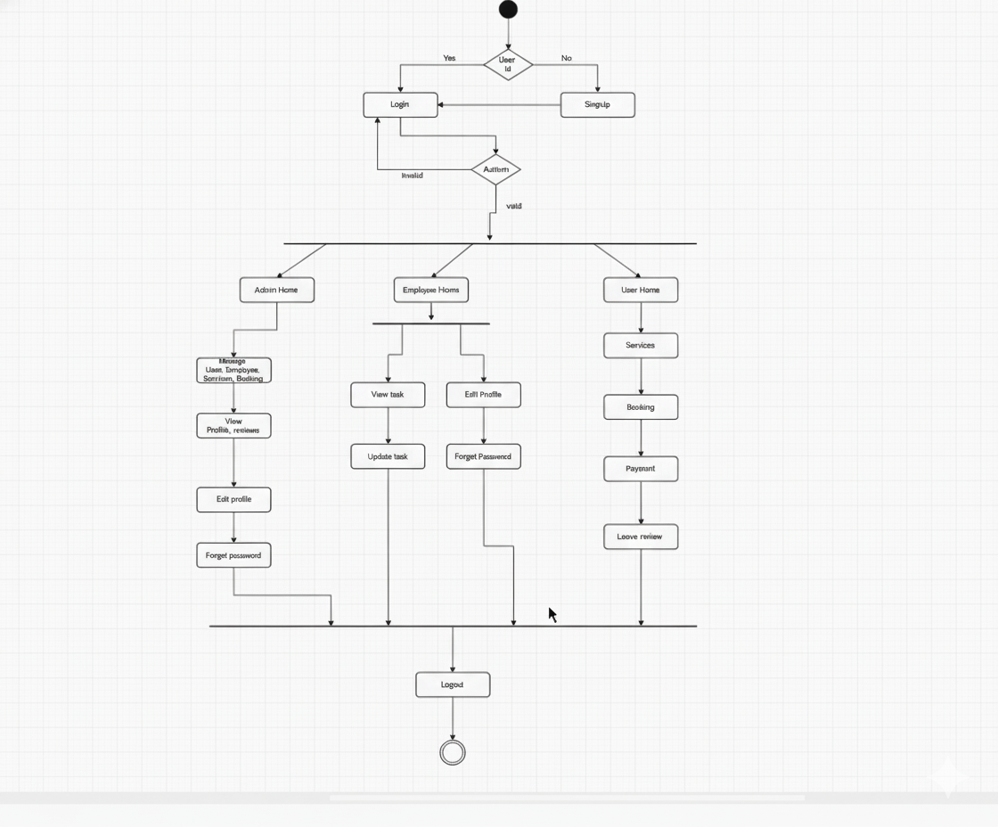

## UI / Wireframe Design using Figma

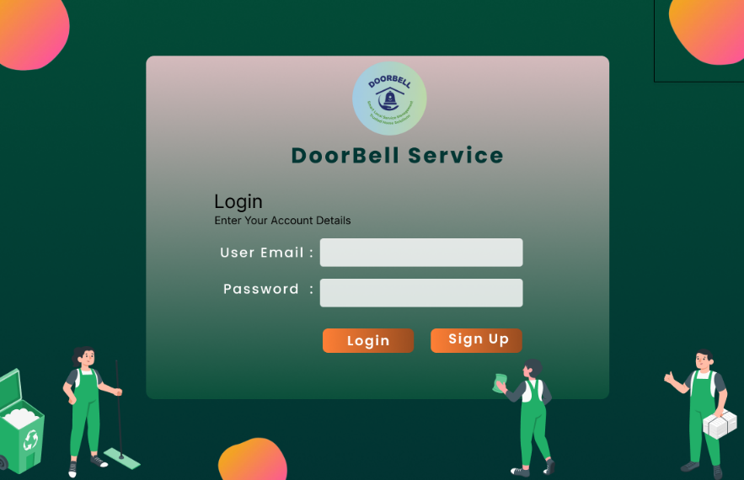 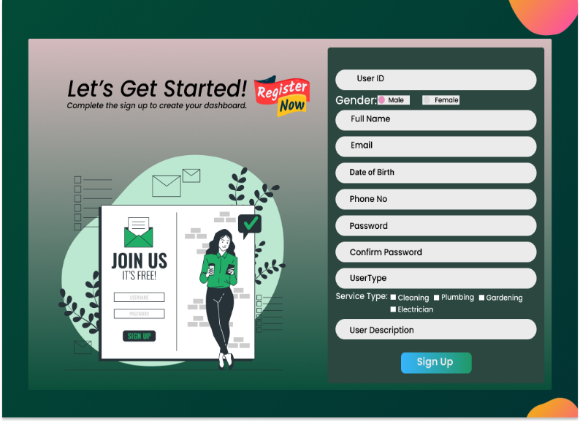

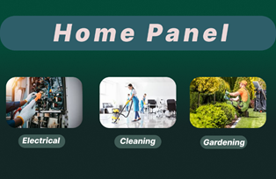 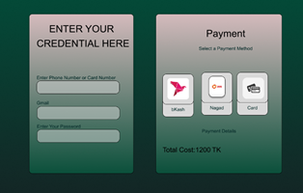

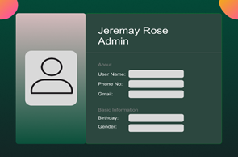 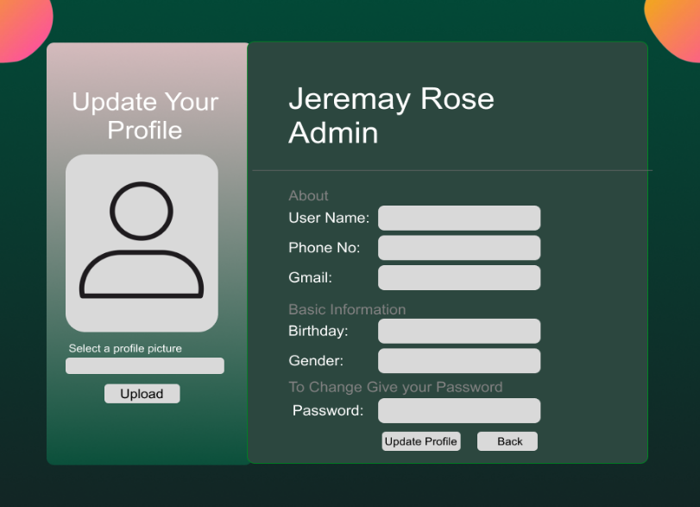

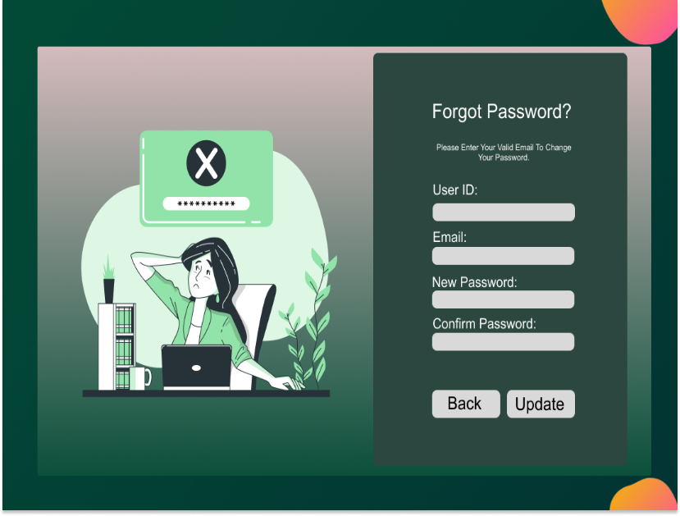 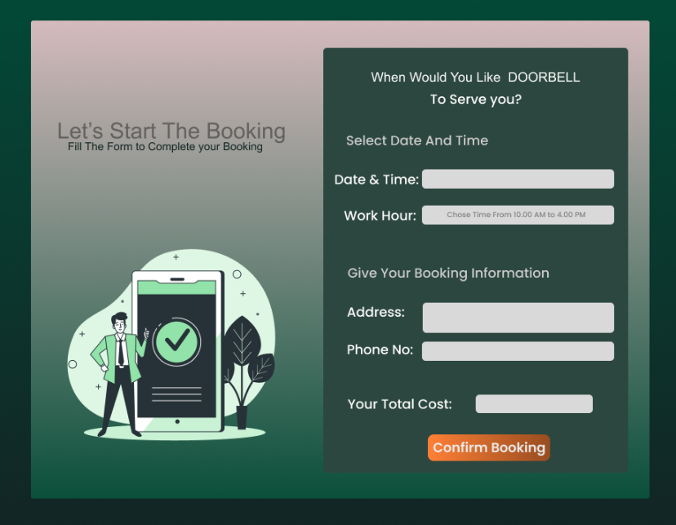

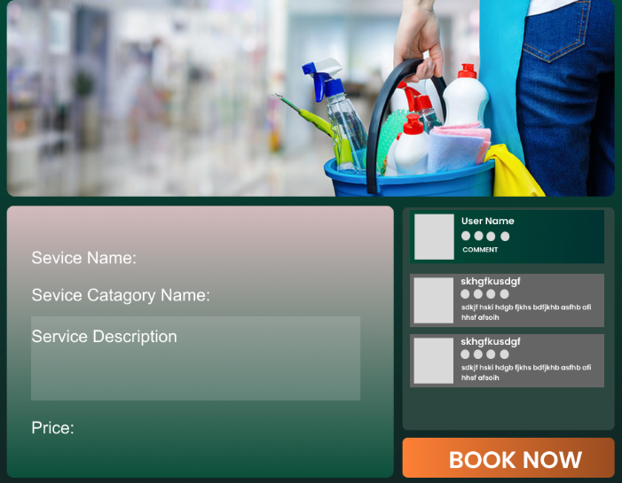 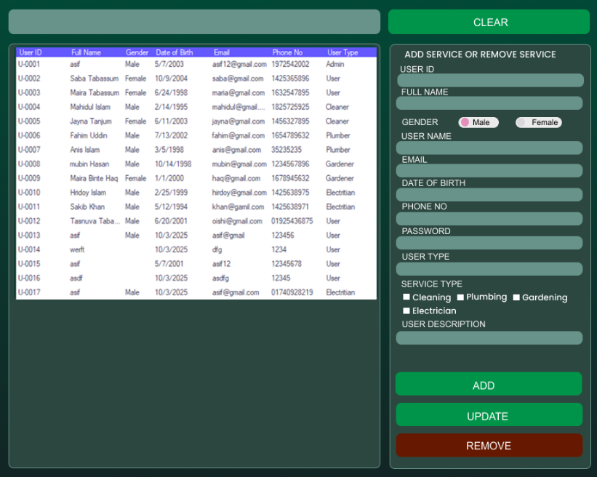

1. GIT WORKFLOW.